Framework Control Design

1. Current (Old) Implementation
The existing system displays all extracted controls in a flat card-based layout without grouping under sections according to framework document. This leads to clutter, excessive scrolling, and poor navigation when the number of controls increases.
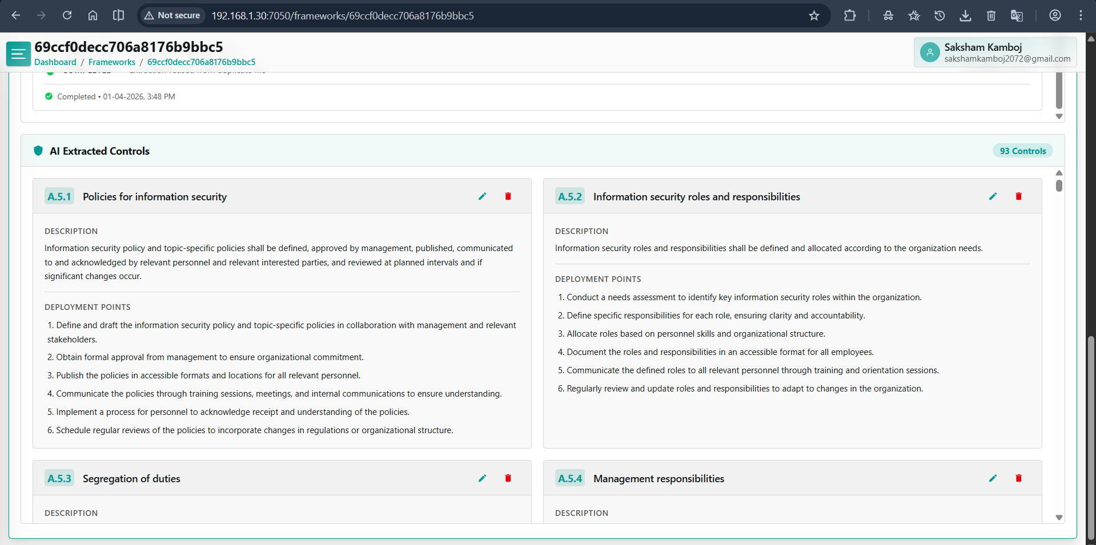

2. Problem with Scaling
When a section contains many controls (e.g., 14+), the card-based UI becomes inefficient. Users struggle to navigate, locate specific controls, and view detailed information quickly.

3. New Proposed UI (Based on Latest Design)
The updated design introduces a structured three-panel layout with clear hierarchy and improved usability:
• Left Panel: Sections list (A.5, A.6, etc.) with control count
• Middle Panel: Compact control list with status indicators
•Right Panel: Detailed view of selected control including description, objective, and deployment points
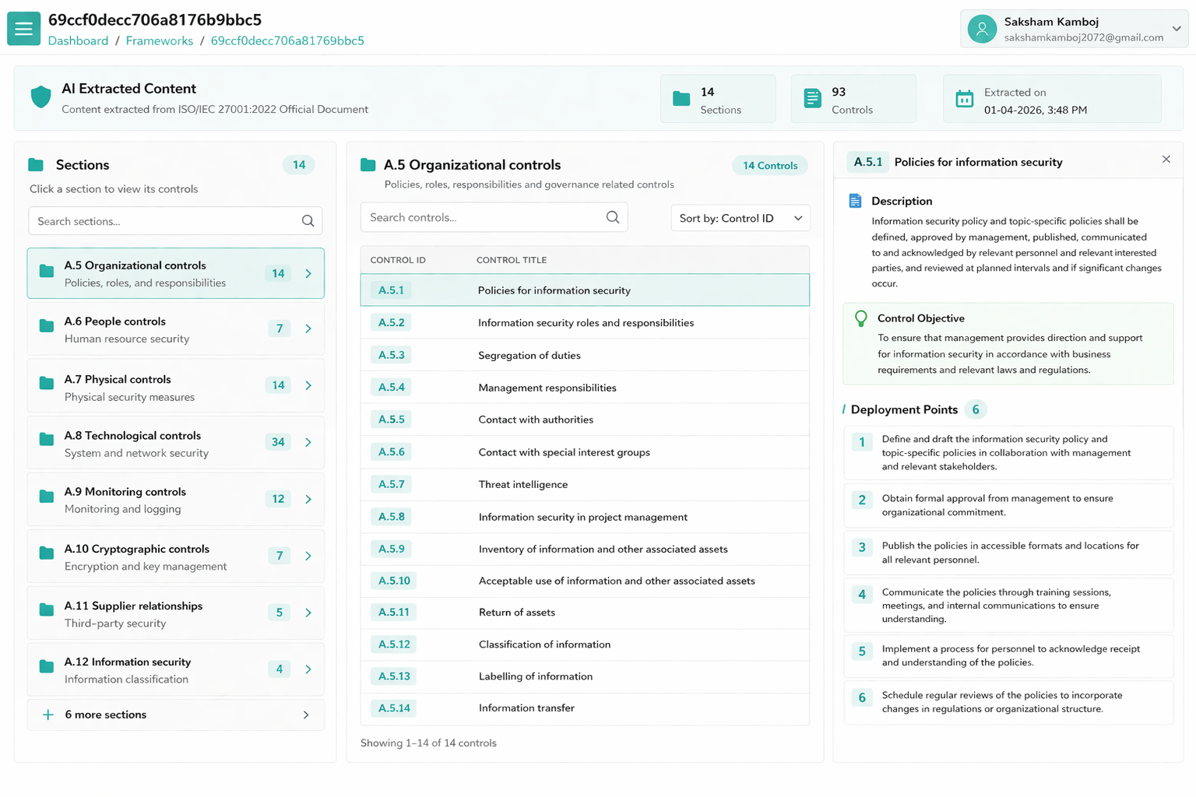

4. Key Features of New Design
• Controls displayed in compact list
• Search, filter, and sorting options
• Split view to avoid scrolling
• Deployment points shown only for selected control

5. User Flow
1. User selects a section from the left panel
2. Middle panel displays all controls under that section
3. User selects a control
4. Right panel displays detailed information and deployment points

6. Benefits
Improves clarity, enhances navigation, supports large datasets, reduces UI clutter, enables faster access to information, and provides a scalable, enterprise-grade user experience.

Prepared By: Saksham Kamboj
Date: 1st April 2026

